3. Online Bus Ticket Booking System
Aim
To design and develop an online bus ticket booking system that allows users to register, log in, search for buses by route and date, view seat availability, book tickets, cancel bookings, and view booking history. The administrator can manage buses, schedules, categories, users, and reports.
Algorithm
- Start the application.
- Display the home page with available buses and routes.
- Allow users to register and log in.
- Enable users to search for buses by source, destination, and journey date.
- Display bus details, categories, timings, fares, and available seats.
- Allow users to select seats and enter passenger details.
- Process payment and confirm the ticket booking.
- Generate a booking confirmation and store the booking details.
- Allow users to cancel tickets and view their booking history.
- Allow users to post comments about buses.
- Allow the administrator to add and update bus information, manage categories, users, and news.
- Generate reports and stop the application.

Code :
<!DOCTYPE html>
<html lang="en">
<head>
<meta charset="UTF-8">
<meta name="viewport" content="width=device-width, initial-scale=1.0">
<title>Online Bus Ticket Booking System</title>

<style>
* {
margin: 0;
padding: 0;
box-sizing: border-box;
font-family: Arial, sans-serif;
}

body {
background: #f4f6f8;
color: #333;
}

header {
background: #12355b;
color: white;
padding: 20px;
text-align: center;
}

header h1 {
margin-bottom: 8px;
}

nav {
background: #0b243e;
padding: 14px;
text-align: center;
position: sticky;
top: 0;
z-index: 100;
}

nav a {
color: white;
text-decoration: none;
margin: 0 10px;
font-weight: bold;
}

nav a:hover {
color: #ffd166;
}

section {
padding: 45px 7%;
}

.title {
text-align: center;
color: #12355b;
margin-bottom: 25px;
}

.container {
max-width: 1100px;
margin: auto;
}

.btn {
display: inline-block;
background: #1479d1;
color: white;
border: none;
padding: 11px 18px;
border-radius: 5px;
cursor: pointer;
text-decoration: none;
}

.btn:hover {
background: #0d5fa8;
}

/* HOME */

.hero {
min-height: 430px;
display: flex;
justify-content: center;
align-items: center;
text-align: center;
color: white;
background:
linear-gradient(rgba(0,0,0,.6), rgba(0,0,0,.6)),
url("https://images.unsplash.com/photo-1544620347-c4fd4a3d5957")
center/cover;
}

.hero h2 {
font-size: 42px;
margin-bottom: 15px;
}

.hero p {
font-size: 19px;
margin-bottom: 25px;
}

/* SEARCH */

.search-box {
background: white;
padding: 25px;
border-radius: 10px;
box-shadow: 0 4px 15px #ccc;
margin-top: -40px;
position: relative;
}

.search-grid {
display: grid;
grid-template-columns: repeat(5, 1fr);
gap: 12px;
}

/* FORMS */

form {
background: white;
padding: 25px;
max-width: 850px;
margin: auto;
border-radius: 10px;
box-shadow: 0 3px 12px #ddd;
}

label {
display: block;
margin-top: 15px;
font-weight: bold;
}

input,
select,
textarea {
width: 100%;
padding: 12px;
margin-top: 6px;
border: 1px solid #ccc;
border-radius: 5px;
}

textarea {
height: 100px;
resize: vertical;
}

form .btn {
margin-top: 20px;
}

/* BUS CARDS */

.bus-grid {
display: grid;
grid-template-columns: repeat(3, 1fr);
gap: 20px;
}

.bus-card {
background: white;
border-radius: 10px;
overflow: hidden;
box-shadow: 0 3px 12px #ddd;
}

.bus-card img {
width: 100%;
height: 180px;
object-fit: cover;
}

.bus-content {
padding: 20px;
}

.bus-content h3 {
color: #12355b;
margin-bottom: 10px;
}

.bus-content p {
margin: 8px 0;
}

.available {
color: green;
font-weight: bold;
}

/* TABLE */

.table-container {
overflow-x: auto;
}

table {
width: 100%;
border-collapse: collapse;
background: white;
box-shadow: 0 3px 12px #ddd;
}

th,
td {
padding: 13px;
border: 1px solid #ddd;
text-align: center;
}

th {
background: #12355b;
color: white;
}

tr:nth-child(even) {
background: #f5f5f5;
}

/* SEATS */

.seat-layout {
background: white;
max-width: 600px;
margin: auto;
padding: 30px;
border-radius: 10px;
box-shadow: 0 3px 12px #ddd;
}

.driver {
background: #12355b;
color: white;
padding: 12px;
text-align: center;
margin-bottom: 20px;
border-radius: 5px;
}

.seats {
display: grid;
grid-template-columns: repeat(4, 1fr);
gap: 12px;
}

.seat {
background: #52b788;
color: white;
padding: 14px;
text-align: center;
border-radius: 5px;
font-weight: bold;
}

.seat.booked {
background: #e63946;
}

.seat.selected {
background: #f4a261;
}

/* DASHBOARD */

.dashboard {
display: grid;
grid-template-columns: repeat(4, 1fr);
gap: 20px;
}

.dashboard-card {
background: white;
padding: 25px;
text-align: center;
border-radius: 10px;
box-shadow: 0 3px 12px #ddd;
}

.dashboard-card h2 {
color: #1479d1;
font-size: 32px;
}

.dashboard-card p {
margin-top: 8px;
}

/* CARDS */

.cards {
display: grid;
grid-template-columns: repeat(3, 1fr);
gap: 20px;
}

.card {
background: white;
padding: 25px;
border-radius: 10px;
box-shadow: 0 3px 12px #ddd;
}

.card h3 {
color: #12355b;
margin-bottom: 10px;
}

.card p {
margin: 8px 0;
}

/* PROFILE */

.profile {
background: white;
max-width: 700px;
margin: auto;
padding: 30px;
border-radius: 10px;
box-shadow: 0 3px 12px #ddd;
}

.profile p {
margin: 14px 0;
}

/* COMMENTS */

.comment {
background: white;
padding: 20px;
margin: 15px auto;
max-width: 800px;
border-radius: 8px;
box-shadow: 0 2px 8px #ddd;
}

.comment h3 {
color: #12355b;
}

.stars {
color: #f4a261;
margin: 8px 0;
}

/* FOOTER */

footer {
background: #0b243e;
color: white;
text-align: center;
padding: 30px;
}

footer p {
margin: 8px;
}

/* RESPONSIVE */

@media (max-width: 900px) {

.search-grid,
.dashboard {
grid-template-columns: repeat(2, 1fr);
}

.bus-grid,
.cards {
grid-template-columns: 1fr;
}
}

@media (max-width: 600px) {

nav a {
display: inline-block;
margin: 6px;
}

.search-grid,
.dashboard {
grid-template-columns: 1fr;
}

.hero h2 {
font-size: 30px;
}

.seats {
grid-template-columns: repeat(2, 1fr);
}
}
</style>
</head>

<body>

<!-- HEADER -->

<header>
<h1>🚌 Online Bus Ticket Booking System</h1>
<p>Book Your Bus Ticket Easily and Quickly</p>
</header>

<!-- NAVIGATION -->

<nav>
<a href="#home">Home</a>
<a href="#search">Search Bus</a>
<a href="#buses">Buses</a>
<a href="#booking">Book Ticket</a>
<a href="#mybooking">My Bookings</a>
<a href="#login">Login</a>
<a href="#register">Register</a>
<a href="#comments">Comments</a>
<a href="#admin">Admin</a>
<a href="#reports">Reports</a>
<a href="#contact">Contact</a>
</nav>

<!-- HOME -->

<section id="home" class="hero">
<div>
<h2>Book Your Bus Ticket</h2>
<p>Search buses, select seats and travel comfortably</p>
<a href="#search" class="btn">Search Buses</a>
</div>
</section>

<!-- SEARCH BUS -->

<section id="search">

<h2 class="title">Search Available Buses</h2>

<div class="search-box">

<div class="search-grid">

<div>
<label>From</label>
<input type="text" placeholder="Departure city">
</div>

<div>
<label>To</label>
<input type="text" placeholder="Destination city">
</div>

<div>
<label>Date</label>
<input type="date">
</div>

<div>
<label>Time</label>
<input type="time">
</div>

<div>
<label>Bus Type</label>
<select>
<option>All</option>
<option>Volvo</option>
<option>Sleeper</option>
<option>Coach</option>
<option>AC Bus</option>
</select>
</div>

</div>

<br>

<center>
<button class="btn">Search Bus</button>
</center>

</div>

</section>

<!-- BUS LIST -->

<section id="buses">

<h2 class="title">Available Buses</h2>

<div class="bus-grid">

<div class="bus-card">

<img src="https://images.unsplash.com/photo-1570125909232-eb263c188f7e">

<div class="bus-content">

<h3>Chennai Express</h3>

<p><b>Route:</b> Chennai → Bangalore</p>
<p><b>Time:</b> 08:00 AM - 02:00 PM</p>
<p><b>Type:</b> Volvo AC</p>
<p><b>Price:</b> ₹650</p>
<p class="available">25 Seats Available</p>

<br>

<a href="#booking" class="btn">Book Now</a>

</div>

</div>

<div class="bus-card">

<img src="https://images.unsplash.com/photo-1544620347-c4fd4a3d5957">

<div class="bus-content">

<h3>South Travels</h3>

<p><b>Route:</b> Chennai → Hyderabad</p>
<p><b>Time:</b> 07:30 PM - 07:00 AM</p>
<p><b>Type:</b> Sleeper Coach</p>
<p><b>Price:</b> ₹1,100</p>
<p class="available">18 Seats Available</p>

<br>

<a href="#booking" class="btn">Book Now</a>

</div>

</div>

<div class="bus-card">

<img src="https://images.unsplash.com/photo-1494515843206-f3117d3f51b7">

<div class="bus-content">

<h3>City Travels</h3>

<p><b>Route:</b> Chennai → Coimbatore</p>
<p><b>Time:</b> 09:00 PM - 05:00 AM</p>
<p><b>Type:</b> AC Coach</p>
<p><b>Price:</b> ₹750</p>
<p class="available">32 Seats Available</p>

<br>

<a href="#booking" class="btn">Book Now</a>

</div>

</div>

</div>

</section>

<!-- BUS CATEGORIES -->

<section>

<h2 class="title">Bus Categories</h2>

<div class="cards">

<div class="card">
<h3>🚍 Volvo Bus</h3>
<p>Comfortable and premium buses with air conditioning.</p>
</div>

<div class="card">
<h3>🛏️ Sleeper Coach</h3>
<p>Suitable for long-distance overnight journeys.</p>
</div>

<div class="card">
<h3>🚌 Regular Coach</h3>
<p>Affordable bus service for daily and regular travel.</p>
</div>

</div>

</section>

<!-- LOGIN -->

<section id="login">

<h2 class="title">User Login</h2>

<form>

<label>Email / Username</label>
<input type="text" placeholder="Enter email or username">

<label>Password</label>
<input type="password" placeholder="Enter password">

<button class="btn">Login</button>

<br><br>

<a href="#">Forgot Password?</a>

</form>

</section>

<!-- REGISTER -->

<section id="register">

<h2 class="title">User Registration</h2>

<form>

<label>Full Name</label>
<input type="text" placeholder="Enter full name">

<label>Email</label>
<input type="email" placeholder="Enter email">

<label>Phone Number</label>
<input type="tel" placeholder="Enter phone number">

<label>Password</label>
<input type="password" placeholder="Create password">

<label>Confirm Password</label>
<input type="password" placeholder="Confirm password">

<button class="btn">Register</button>

</form>

</section>

<!-- BOOK TICKET -->

<section id="booking">

<h2 class="title">Book Bus Ticket</h2>

<form>

<label>Bus</label>

<select>
<option>Chennai Express - Chennai to Bangalore</option>
<option>South Travels - Chennai to Hyderabad</option>
<option>City Travels - Chennai to Coimbatore</option>
</select>

<label>Journey Date</label>
<input type="date">

<label>Boarding Point</label>
<select>
<option>Chennai Central</option>
<option>Koyambedu</option>
<option>Guindy</option>
</select>

<label>Dropping Point</label>
<select>
<option>Bangalore Central</option>
<option>Electronic City</option>
<option>Majestic</option>
</select>

<label>Select Seat</label>
<select>
<option>Seat 01</option>
<option>Seat 02</option>
<option>Seat 03</option>
<option>Seat 04</option>
<option>Seat 05</option>
</select>

<label>Number of Passengers</label>
<input type="number" min="1" max="10">

<label>Passenger Name</label>
<input type="text" placeholder="Enter passenger name">

<label>Passenger Age</label>
<input type="number">

<label>Passenger Gender</label>
<select>
<option>Male</option>
<option>Female</option>
<option>Other</option>
</select>

<label>Phone Number</label>
<input type="tel" placeholder="Enter phone number">

<button class="btn">Proceed to Payment</button>

</form>

</section>

<!-- SEAT SELECTION -->

<section>

<h2 class="title">Select Your Seat</h2>

<div class="seat-layout">

<div class="driver">
DRIVER
</div>

<div class="seats">

<div class="seat">01</div>
<div class="seat">02</div>
<div class="seat booked">03</div>
<div class="seat">04</div>

<div class="seat">05</div>
<div class="seat">06</div>
<div class="seat booked">07</div>
<div class="seat">08</div>

<div class="seat">09</div>
<div class="seat selected">10</div>
<div class="seat">11</div>
<div class="seat">12</div>

<div class="seat booked">13</div>
<div class="seat">14</div>
<div class="seat">15</div>
<div class="seat">16</div>

</div>

<br>

<p>🟩 Available</p>
<p>🟥 Booked</p>
<p>🟧 Selected</p>

</div>

</section>

<!-- PAYMENT -->

<section>

<h2 class="title">Payment</h2>

<form>

<label>Booking Amount</label>
<input type="text" value="₹650" readonly>

<label>Payment Method</label>

<select>
<option>UPI</option>
<option>Credit Card</option>
<option>Debit Card</option>
<option>Net Banking</option>
</select>

<label>Card / UPI Details</label>
<input type="text" placeholder="Enter payment details">

<button class="btn">Make Payment</button>

</form>

</section>

<!-- MY BOOKINGS -->

<section id="mybooking">

<h2 class="title">My Booking History</h2>

<div class="table-container">

<table>

<tr>
<th>Booking ID</th>
<th>Bus</th>
<th>Route</th>
<th>Date</th>
<th>Seat</th>
<th>Amount</th>
<th>Status</th>
<th>Action</th>
</tr>

<tr>
<td>BK1001</td>
<td>Chennai Express</td>
<td>Chennai - Bangalore</td>
<td>15-10-2026</td>
<td>10</td>
<td>₹650</td>
<td>Confirmed</td>
<td>
<button class="btn">Cancel</button>
</td>
</tr>

<tr>
<td>BK1002</td>
<td>South Travels</td>
<td>Chennai - Hyderabad</td>
<td>20-10-2026</td>
<td>05</td>
<td>₹1,100</td>
<td>Confirmed</td>
<td>
<button class="btn">Cancel</button>
</td>
</tr>

<tr>
<td>BK1003</td>
<td>City Travels</td>
<td>Chennai - Coimbatore</td>
<td>05-09-2026</td>
<td>12</td>
<td>₹750</td>
<td>Completed</td>
<td>
<button class="btn">View</button>
</td>
</tr>

</table>

</div>

</section>

<!-- CANCEL BOOKING -->

<section>

<h2 class="title">Cancel Booking</h2>

<form>

<label>Booking ID</label>
<input type="text" placeholder="Enter booking ID">

<label>Reason for Cancellation</label>

<textarea placeholder="Enter cancellation reason"></textarea>

<button class="btn">Cancel Ticket</button>

</form>

</section>

<!-- USER PROFILE -->

<section>

<h2 class="title">My Profile</h2>

<div class="profile">

<h3>User Information</h3>

<p><b>Name:</b> Naveen Kumar</p>
<p><b>Email:</b> naveen@example.com</p>
<p><b>Phone:</b> 9876543210</p>
<p><b>Total Bookings:</b> 5</p>
<p><b>Cancelled Bookings:</b> 1</p>

<button class="btn">Edit Profile</button>

</div>

</section>

<!-- COMMENTS -->

<section id="comments">

<h2 class="title">Bus Comments & Reviews</h2>

<form>

<label>Select Bus</label>

<select>
<option>Chennai Express</option>
<option>South Travels</option>
<option>City Travels</option>
</select>

<label>Your Comment</label>

<textarea placeholder="Write your comment"></textarea>

<label>Rating</label>

<select>
<option>★★★★★ - Excellent</option>
<option>★★★★☆ - Good</option>
<option>★★★☆☆ - Average</option>
<option>★★☆☆☆ - Poor</option>
<option>★☆☆☆☆ - Very Poor</option>
</select>

<button class="btn">Post Comment</button>

</form>

<br>

<div class="comment">

<h3>Naveen Kumar</h3>
<div class="stars">★★★★★</div>
<p>Very comfortable journey and good bus service.</p>

</div>

<div class="comment">

<h3>Rahul</h3>
<div class="stars">★★★★☆</div>
<p>The bus was clean and reached the destination on time.</p>

</div>

</section>

<!-- ADMIN DASHBOARD -->

<section id="admin">

<h2 class="title">Admin Dashboard</h2>

<div class="dashboard">

<div class="dashboard-card">
<h2>120</h2>
<p>Total Buses</p>
</div>

<div class="dashboard-card">
<h2>85</h2>
<p>Available Buses</p>
</div>

<div class="dashboard-card">
<h2>540</h2>
<p>Registered Users</p>
</div>

<div class="dashboard-card">
<h2>320</h2>
<p>Today's Bookings</p>
</div>

</div>

</section>

<!-- ADMIN BUS MANAGEMENT -->

<section>

<h2 class="title">Manage Bus Information</h2>

<div class="table-container">

<table>

<tr>
<th>Bus ID</th>
<th>Bus Name</th>
<th>Category</th>
<th>Route</th>
<th>Seats</th>
<th>Available</th>
<th>Action</th>
</tr>

<tr>
<td>BUS001</td>
<td>Chennai Express</td>
<td>Volvo</td>
<td>Chennai - Bangalore</td>
<td>40</td>
<td>25</td>
<td>
<button class="btn">Edit</button>
<button class="btn">Delete</button>
</td>
</tr>

<tr>
<td>BUS002</td>
<td>South Travels</td>
<td>Sleeper</td>
<td>Chennai - Hyderabad</td>
<td>36</td>
<td>18</td>
<td>
<button class="btn">Edit</button>
<button class="btn">Delete</button>
</td>
</tr>

</table>

</div>

</section>

<!-- ADD / UPDATE BUS -->

<section>

<h2 class="title">Add / Update Bus</h2>

<form>

<label>Bus ID</label>
<input type="text" placeholder="Enter bus ID">

<label>Bus Name</label>
<input type="text" placeholder="Enter bus name">

<label>Bus Category</label>

<select>
<option>Volvo</option>
<option>Sleeper Coach</option>
<option>Regular Coach</option>
<option>AC Bus</option>
</select>

<label>Bus Photo</label>
<input type="file">

<label>Route / Location</label>
<input type="text" placeholder="Enter route">

<label>Departure Time</label>
<input type="time">

<label>Arrival Time</label>
<input type="time">

<label>Total Seats</label>
<input type="number">

<label>Available Seats</label>
<input type="number">

<label>Ticket Price</label>
<input type="number" placeholder="Enter ticket price">

<label>Description</label>
<textarea placeholder="Enter bus description"></textarea>

<button class="btn">Add Bus</button>
<button class="btn">Update Bus</button>

</form>

</section>

<!-- MANAGE USERS -->

<section>

<h2 class="title">Manage Registered Users</h2>

<div class="table-container">

<table>

<tr>
<th>User ID</th>
<th>Name</th>
<th>Email</th>
<th>Phone</th>
<th>Bookings</th>
<th>Status</th>
<th>Action</th>
</tr>

<tr>
<td>U001</td>
<td>Naveen Kumar</td>
<td>naveen@example.com</td>
<td>9876543210</td>
<td>5</td>
<td>Active</td>
<td><button class="btn">View</button></td>
</tr>

<tr>
<td>U002</td>
<td>Rahul</td>
<td>rahul@example.com</td>
<td>9876501234</td>
<td>8</td>
<td>Active</td>
<td><button class="btn">View</button></td>
</tr>

</table>

</div>

</section>

<!-- ADMIN BOOKING MANAGEMENT -->

<section>

<h2 class="title">Manage Bookings</h2>

<div class="table-container">

<table>

<tr>
<th>Booking ID</th>
<th>User</th>
<th>Bus</th>
<th>Route</th>
<th>Date</th>
<th>Seat</th>
<th>Payment</th>
<th>Status</th>
</tr>

<tr>
<td>BK1001</td>
<td>Naveen Kumar</td>
<td>Chennai Express</td>
<td>Chennai - Bangalore</td>
<td>15-10-2026</td>
<td>10</td>
<td>Paid</td>
<td>Confirmed</td>
</tr>

<tr>
<td>BK1002</td>
<td>Rahul</td>
<td>South Travels</td>
<td>Chennai - Hyderabad</td>
<td>20-10-2026</td>
<td>05</td>
<td>Paid</td>
<td>Confirmed</td>
</tr>

</table>

</div>

</section>

<!-- REPORT GENERATION -->

<section id="reports">

<h2 class="title">Report Generation</h2>

<form>

<label>Report Type</label>

<select>
<option>Daily Booking Report</option>
<option>Monthly Booking Report</option>
<option>Bus Availability Report</option>
<option>User Report</option>
<option>Cancellation Report</option>
<option>Payment Report</option>
</select>

<label>From Date</label>
<input type="date">

<label>To Date</label>
<input type="date">

<button class="btn">Generate Report</button>

</form>

</section>

<!-- NEWS -->

<section>

<h2 class="title">Latest News</h2>

<div class="cards">

<div class="card">
<h3>Festival Special Buses</h3>
<p>Additional buses are available during festival seasons.</p>
</div>

<div class="card">
<h3>New Routes</h3>
<p>New routes between major cities are now available.</p>
</div>

<div class="card">
<h3>Special Offers</h3>
<p>Get special discounts on selected bus routes.</p>
</div>

</div>

</section>

<!-- CONTACT -->

<section id="contact">

<h2 class="title">Contact Us</h2>

<form>

<label>Name</label>
<input type="text" placeholder="Enter your name">

<label>Email</label>
<input type="email" placeholder="Enter email">

<label>Subject</label>
<input type="text" placeholder="Enter subject">

<label>Message</label>
<textarea placeholder="Enter your message"></textarea>

<button class="btn">Send Message</button>

</form>

<br>

<div class="card container">

<h3>Bus Booking Office</h3>

<p>📍 Chennai, Tamil Nadu, India</p>
<p>📞 +91 98765 43210</p>
<p>📧 support@busbooking.com</p>
<p>🕒 24 × 7 Customer Support</p>

</div>

</section>

<!-- FOOTER -->

<footer>

<h3>🚌 Online Bus Ticket Booking System</h3>

<p>Search • Book • Pay • Travel • Manage</p>

<p>© 2026 Online Bus Ticket Booking System. All Rights Reserved.</p>

</footer>

</body>
</html>
Output :
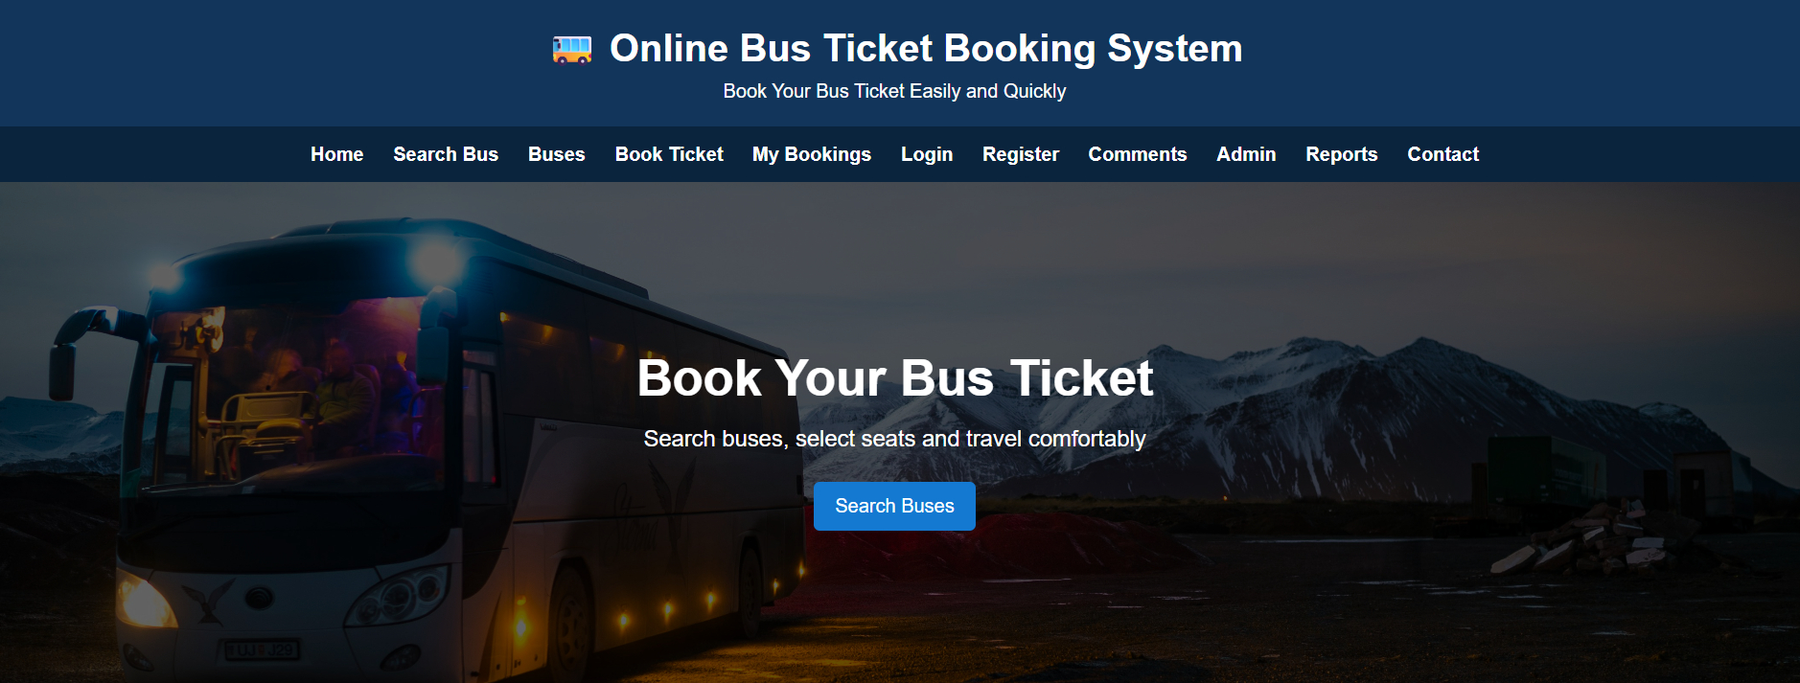
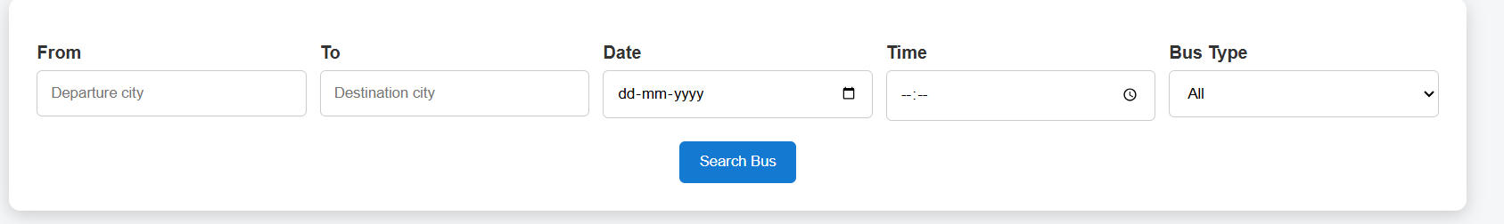
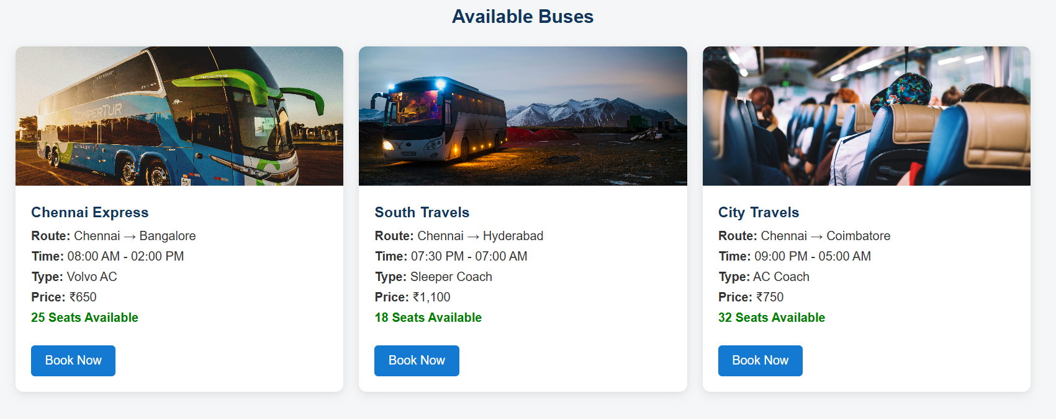
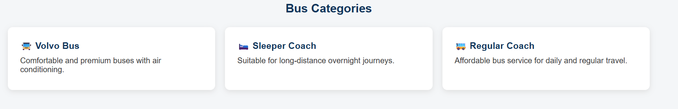
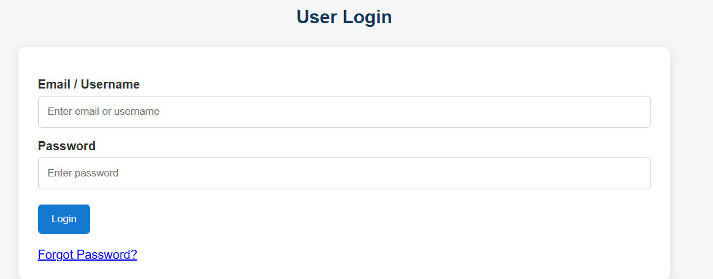
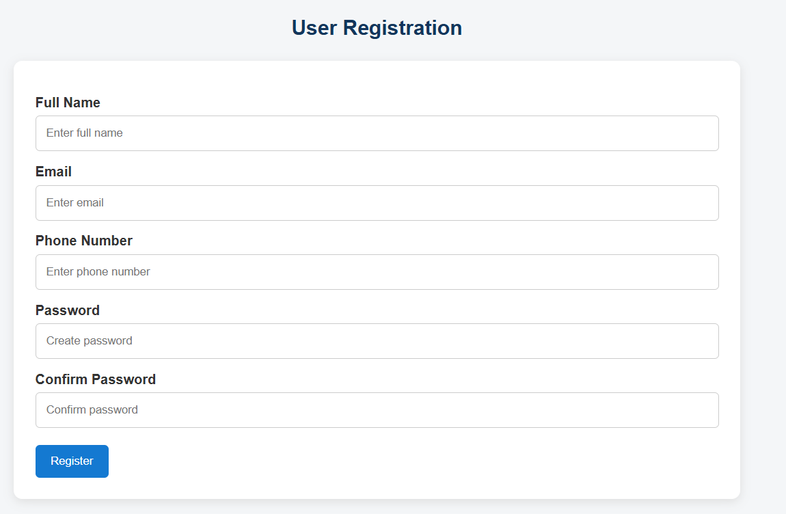

Result : Online Bus Ticket Booking System successfully designed

